Project Design Phase Solution Architecture
Date | 14 February 2026
Team ID | LTVIP2026TMIDS65779
Project Name | Online payment Fraud detection using machine learning
Maximum Marks | 4 Marks

Overview
The solution architecture bridges business goals (reducing online payment fraud and protecting customers/financial institutions) and the technical implementation (data preprocessing, machine learning models, and API-based integration). The architecture defines system components, transaction flow, interfaces, and deployment considerations.

Key Goals
- Provide accurate real-time fraud detection for online transactions
- Minimize false positives while maximizing fraud detection rate
- Ensure modularity across preprocessing, model, and API layers
- Enable scalability for high transaction volumes
- Maintain reproducibility via saved artifacts (model, scaler, encoder)

Architecture Components
Frontend (UI): Web dashboard for monitoring transactions and viewing fraud alerts. Backend (API Layer): Flask/FastAPI server handling transaction requests, validation, and routing.
Preprocessing Layer: Imputer, Encoder, Scaler, and feature engineering modules to prepare transaction data consistently.
ML Model Layer: Trained fraud detection classifier (Logistic Regression / Random Forest / XGBoost).
Database & Artifacts: Transaction records stored in database; serialized ML model files (.pkl/.joblib) for inference.
Alert System: Notification module for flagging suspicious transactions.

Data Flow
1)User initiates an online payment transaction.
2)Backend API receives transaction details and validates inputs.
3)Transaction data passes through preprocessing (cleaning, encoding, scaling, feature generation).
4)Preprocessed features are sent to the ML model for fraud probability prediction.
5)System classifies transaction as Fraud or Legitimate.
6)Result is stored in database and alert is triggered if fraud is detected.

Solution Architecture Diagram
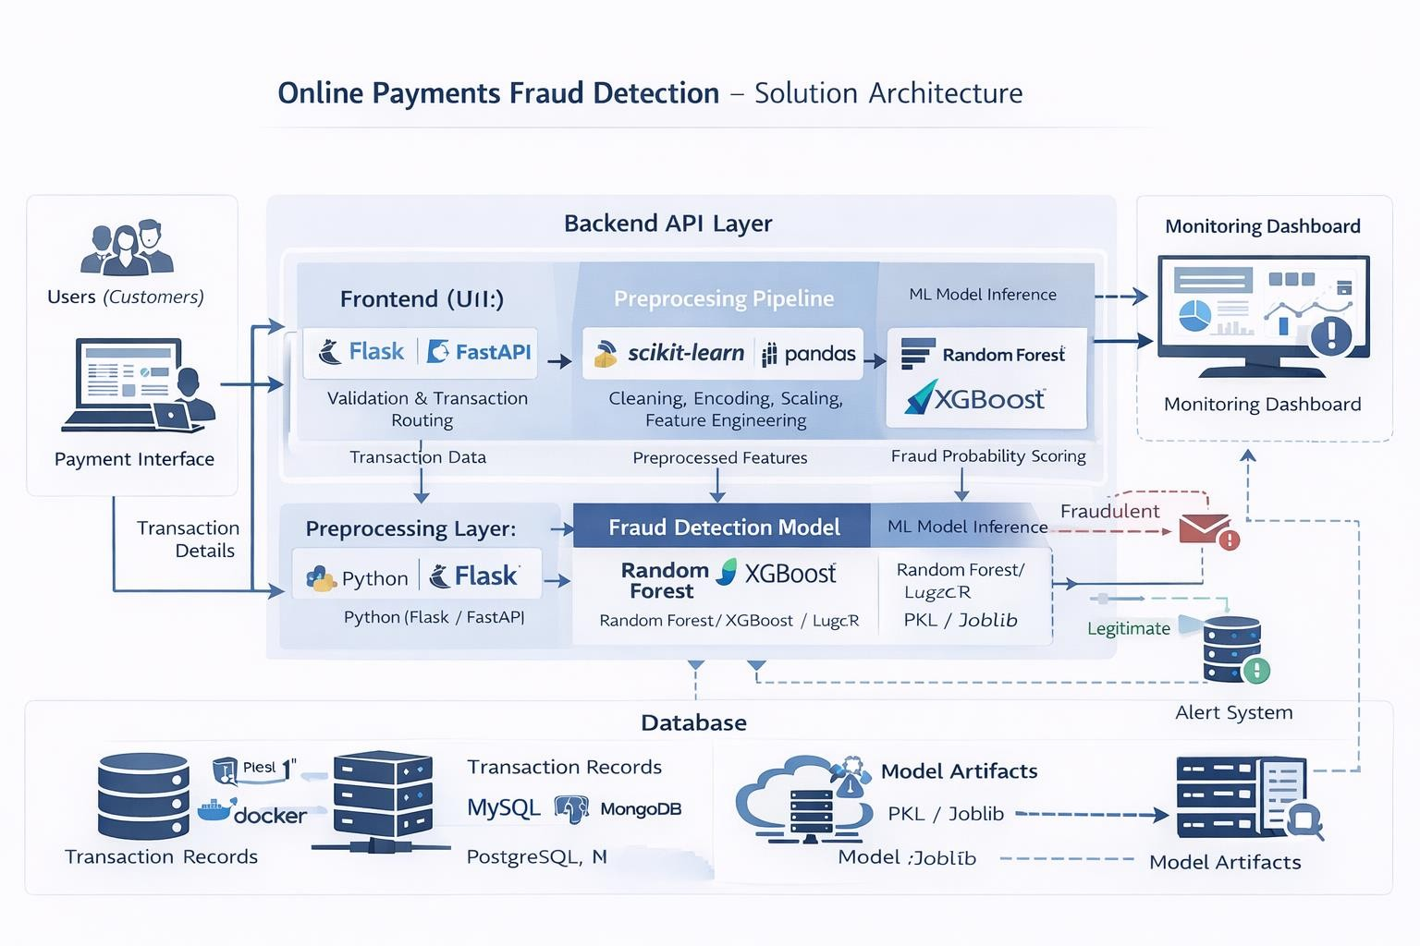

Non-Functional Considerations
- Performance: Real-time low-latency fraud prediction (<1 second per transaction)
- Reliability: Consistent preprocessing using saved artifacts
- Security: Encrypted transaction handling, input validation, authentication
- Maintainability: Modular and well-documented architecture
- Scalability: Cloud-ready design supporting high transaction loads
- Deployability: Compatible with Docker, Cloud VMs, and container orchestration in future

